
24 Hospital Lane, Calais, ME 04619

Financial Assistance Application Form Instructions

Thank you for requesting an application for Financial Assistance. There are a few things we must have before a determination can be made. You must be a Maine resident to apply for financial assistance.

We must have proof of all sources of income as follows:
- Household Income: All members of the household must be included on the application along with their proof of income. (Note: If anyone else can claim you as a dependent, that person must be included on the application along with their proof of income.)
- If you are actively employed or self-employed, please attach BOTH of the following types of documentation to your application:
  - Confirmation of income earned in the last 3 months, such as paystubs.
  - Confirmation of your annual income; your 2024 tax return AND copies of your W-2’s and 1099’s as applicable
- If you are receiving social security, pensions, or other forms of retirement income, we must have a copy of the check received or a bank statement showing the deposits made. We will also accept a copy of your yearly benefit statement from the Social Security Administration.
- If you are living on savings accounts or investments, we need two consecutive months’ statements to show that you are spending those funds to meet daily expenses.
- If you are unemployed and not receiving any income, we need a letter of support written by the person supplying your day-to-day needs.
- If you are receiving unemployment benefits, we must have a copy of the check or determination letter.

The hospital reserves the right to an independent verification of income. It will be necessary for you to complete and sign form 4506T-EZ Short form request for Individual Tax Return Transcript (attached).

It will be necessary for you to apply for Mainecare due to the expanded Mainecare program for service rendered after 1-1-2019.

If you have already applied for Mainecare, please include a copy of their determination letter.

If you fail to provide the requested information your application will be deferred for 60 days. If you do not respond in 60 days your application will be denied. Please make sure you sign and date the application.

If you need assistance in completing the form, please feel free to call us.

207-454-9351 Financial Counseling Office
207-454-9348 Patient Financial Services

Please mail to Attn: Free Care, CCH, 24 Hospital Drive, Calais, ME 04619

Calais Community Hospital Financial Assistance Application
Applicant(s) Name(s):
Last | First |  |  | MI | DOB |  | Social Security Number
1.
2.
Address |  | City |  |  |  |  | State | Zip
Please list additional members in household: |  | Relationship |  |  |  | Date of Birth: |  | Claimed on Taxes?
GROSS INCOME | Household | Other |  |  |  | ASSETS
Weekly Salary |  |  |  |  |  | Checking/Savings
Dividends/Interest |  |  |  |  |  | Real Estate
Gross Rental Income |  |  |  |  |  | Automobiles
Self-Employment |  |  |  |  |  | Life Insurance
Social Security/Disability |  |  |  |  |  | Other Vehicles, etc.
Workers Compensation |  |  |  |  |  | MAINECARE COVERAGE
Unemployment |  |  |  |  |  | Have you applied for Mainecare?  ______Yes ______No (Check one)  If you answered “Yes” to any of the questions on page 1, you will need to provide us with a formal denial letter from Mainecare.
Alimony/Child Support
Other Income
*ATTACH DOCUMENTATION  FOR ALL ENTRIES ABOVE* | TOTAL  $ | TOTAL  $
I/We certify that all the information given is true and complete. I/We give permission Calais Community Hospital to verify any facts pertaining to the provided information. PLEASE ATTACH ANY ADDITIONAL DOCUMENTATION THAT EXPLAINS YOUR FINANCIAL SITUATION.
↓↓Please sign here: Date:

THIS SECTION FOR OFFICE USE ONLY – DO NOT COMPLETE
Process Date: ____________________

Total Annual Gross Income: _______________________ Number of Dependents: ______________

APPROVAL _______  Other comments | DEFERRAL _______  Mainecare Denial _____  Proof of Income _____ | DENIAL _______  Over Income _____  Other ___________________
Coverage Period:_____________________ Next Application Date:__________________

Processor Signature:_______________________________________________________

VP of Finance Signature:____________________________________________________

FINANCIAL ASSISTANCE FOR THOSE UNABLE TO PAY

Calais Community Hospital (CCH) is committed to treating all patients who need our care regardless of their health insurance or financial status. In addition, we offer services to help you arrange for payment of your bill, from insurance billing to payment plans, and even financial assistance, which may qualify you to have all, or part of your bill written off.

CCH gives financial assistance to Maine people with family income at 200% or less of the Federal Poverty Income Guidelines as Free Care.
Size of family unit & income guidelines:

200% FPL
100% discount
1 $31,300.00
2 $42,300.00
3 $53,300.00
4 $64,300.00
5 $75,300.00
6 $86,300.00
7 $97,300.00
8 $108,300.00

Add $11,000.00 for each family member.

To apply for Financial Assistance, contact the CCH Patient Financial Counselor at
207-454-9351 or online at www.calaishospital.org.

You will be asked if you have insurance of any kind to help pay for your care. You may also be asked to show that insurance or a government program will not pay for your care.

Only necessary medical care is covered under our financial assistance program.
If you do not qualify for financial assistance, you are entitled to ask for a fair hearing. We will tell you how to apply for a fair hearing.
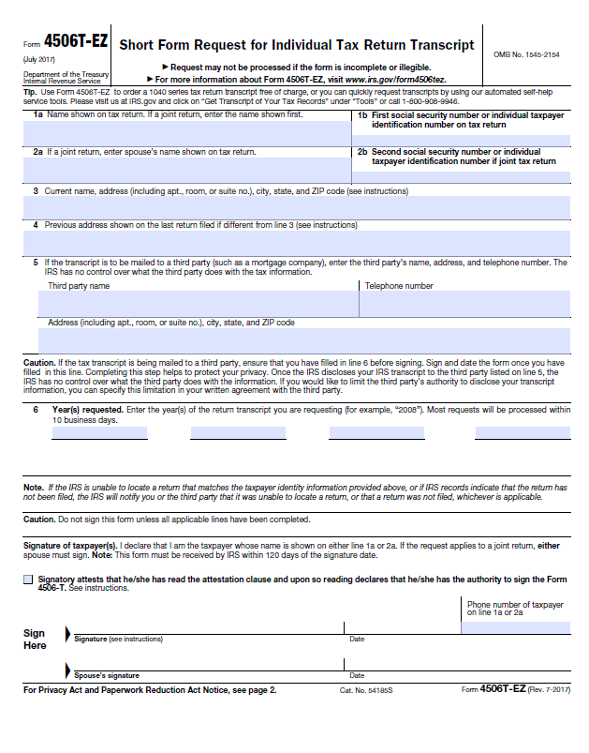

Calais Community Hospital (CCH) complies with applicable Federal civil rights laws and does not discriminate on the basis of race, color, national origin, ethnicity, age, mental or physical ability or disability, political affiliation, religion, culture, socio-economic status, genetic information, veteran status, sexual orientation, sex, gender, gender identity or expression, or language. CCH does not exclude people or treat them differently because of race, color, national origin, ethnicity, age, mental or physical ability or disability, political affiliation, religion, culture, socio-economic status, genetic information, veteran status, sexual orientation, sex, gender, gender identity or expression, or language.

Calais Community Hospital
- Provides free aids and services to people with disabilities to communicate effectively with us, such as:
○ Qualified sign language interpreters
○ Written information in other formats (large print, audio, accessible electronic formats, other formats)
- Provides free language services to people whose primary language is not English, such as:
- Qualified interpreters
- Information written in other languages.

If you need these services, contact the hospital at 207-454-7521.

If you believe that Calais Community Hospital has failed to provide these services or discriminated in another way on the basis of race, color, national origin, age, disability, or sex, you can file a grievance with: Compliance Officer at 207-255-0272, or fax to 207-255-0214. You can file a grievance in person or by mail, fax, or email. If you need help filing a grievance the Compliance Officer is available to help you.

You can also file a civil rights complaint with the U.S. Department of Health and Human Services, Office for Civil Rights, electronically through the Office for Civil Rights Complaint Portal, available at https://ocrportal.hhs.gov/ocr/portal/lobby.jsf, or by mail or phone at:
U.S. Department of Health and Human Services, 200 Independence Avenue, SW, Room 509F, HHH Building, Washington, D.C. 20201, 1-800-368-1019, 800-537-7697 (TDD). Complaint forms are available at http://www.hhs.gov/ocr/office/file/index.html.
English Translation: You have the right to an interpreter at no cost to you. Please point to your language





















